**Year 12 Chemistry Topic Test #3 (Organic) - 2012**

Name: **ANSWERS** Mark = _____ / 55

# Part 1: Multiple Choice Section 5 marks

___________________________________________________________________________________

1. **A** 2. **A** 3. **D** 4. **D** 5. **B** **✓ each**

**Part 2: Short Answer Section 50 marks**

___________________________________________________________________________________

1. Write fully balanced equations for any reactions that occur in the following procedures. If no

reaction occurs, write ‘no reaction’. Write the name of any organic product formed.

(a) The combustion of octane in excess oxygen

*Equation:* **2 CH3(CH2)6CH3 + 25 O2 → 16 CO2 + 18 H2O ✓✓**

(b) Propan-1-ol is added to methanoic acid in the presence of concentrated sulfuric acid.

*Equation:* **HCOOH + CH3CH2CH2OH → HCOOCH2CH2CH3 + H2O ✓✓**

*Name of organic product:* **1-propyl methanoate ✓**

(2+2+1 = 5 marks)

2. Complete the table below by naming a reactant that will react with the reactant in column 1 to give the product in column 3.

|  |  |  |
| --- | --- | --- |
| *Reactant 1* | *Reactant 2* | *Product formed* |
| ethene | **water** | ethanol |
| propene | **hydrogen chloride** | 2-chloropropane |
| ethanol | **propanoic acid** | ethyl propanoate |
| butanoic acid | **propan-1-ol** | 1-propylbutanoate |

**✓ each** (4 marks)

3. Give the order of the boiling points of these chemicals, numbering them 1 to 6, with 6 being the highest value.

|  |  |
| --- | --- |
| *Compounds* | *Order of boiling points (1 – 6)* |
| butan-1-ol | **5** |
| methylpropane | **1** |
| butanoic acid | **6** |
| butan-2-ol | **4** |
| butane | **2** |
| butanal | **3** |

**✓each** (6 marks)

4. Use the following condensed structural formulae to answer the questions that follow:

**A** CH3CH2CH2CH2CH2OH ***1° alcohol***

**B** CH3CH(OH)CH2CH2CH3 ***2° alcohol***

**C** CH3CH(OH)CH(CH3)CH3 ***2° alcohol***

**D** CH3C(CH3)2CH2OH ***1° alcohol***

**E** CH3C(OH)CH2CH3 ***3° alcohol***

|

CH3

Choose which compounds (**A**, **B**, **C**, **D** or **E**) which will give each of the following reactions (there may be more than one answer in each case)

(a) Which compound(s) react with a warm solution containing sulfuric

acid and potassium dichromate to produce a carboxylic acid. **A, D ✓✓**

(b) Which compound(s) react with a warm solution containing sulfuric

acid and potassium dichromate to produce a ketone. **B, C ✓✓**

(c) Which compound(s) would show no visible signs of a reaction

with a warm solution containing sulfuric acid and

potassium dichromate. **E** **✓**

(d) Write the structure and name for the oxidation product of **C** with acidified potassium

permanganate.

*structure* **CH3COCH(CH3)CH3****✓***name* **3-methybutan-2-one ✓**

(e) Write the equation for the reaction between **D** and methanoic acid in the presence of

concentrated sulfuric acid.

**CH3C(CH3)2CH2OH + HCOOH → HCOOCH2C(CH3)3 + H2O ✓✓**

(f) Class alcohols **C** and **E** as primary (1o), secondary (2o) or tertiary (3o)

|  |  |
| --- | --- |
| *Alcohols* | *Class* |
| C | **2° ✓** |
| E | **3° ✓** |

(11 marks)

5. Write IUPAC names for the following compounds.

|  |  |
| --- | --- |
| *Compounds* | *Names* |
| CH3CH2COOCH3 | **methyl propanaoate** |
| (CH3)3CH | **methylpropane** |
| CH3CH(CH3)CH2CH2COCH3 | **5-methylhexan-2-one** |

**✓ each** (3 marks)

6. Draw a piece of polymer using but-1-ene as the monomer; show 3 repeating units.

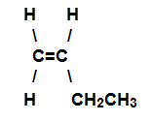

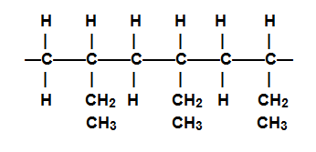 **✓✓**

(2 marks)

7. An organic compound X has an empirical formula C2H4O.

0.0278 mol of this compound has a mass 2.45 g.

(a) What is the molecular formula of compound X? Show all working.

**EFM = 44.05 ✓**

**M(X) = m/n = 2.45/0.0278 = 88.13 g mol−1 ✓**

**∴ MF = 2 x EF = C4H8O2 ✓**

(b) Compound X has several isomers.

(i) Isomer 1 is a sweet smelling liquid which was prepared using propan-2-ol as one

of its reactants. Give structure of isomer 1.

*structure* 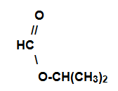  **✓**

(ii) Isomer 2 is also a sweet smelling liquid but ethanoic acid was used in its

preparation. Give structure and name of isomer 2.

*structure* 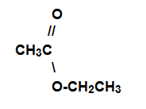 **✓**

*name*  **ethyl ethanoate ✓**

(iii) Isomer 3 gives off a gas when added to solid sodium carbonate.

Give structure and name of isomer 3.

*structure* 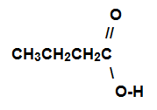 **✓**

*name*  **butanoic acid ✓**

(3 + 5 = 8 marks)

8. Two **α-amino acids** are shown below

|  |  |
| --- | --- |
|  |  |

(a) A chemical is said to be amphoteric if it can react with an acid and a base.

Glycine can be classed as an amphoteric chemical.

Using equations illustrate the amphoteric property of glycine

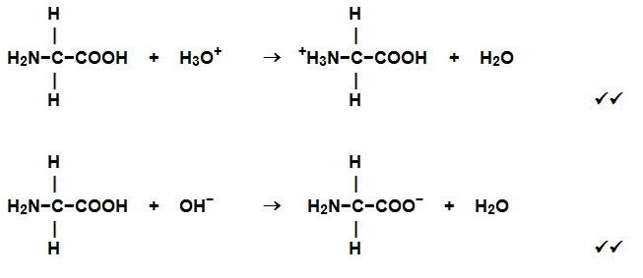

(b) Draw a piece of condensation polymer between glycine and alanine molecules.

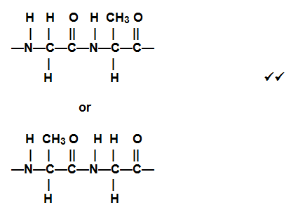

(4 + 2 = 6 marks)

9. Here is the structure of a typical saturated triglyceride fat;

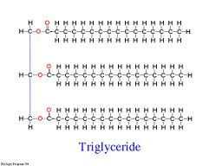

(a) What is the important functional group in this molecule? **ester ✓**

(b) An important reaction of such fats and oils is hydrolysis by reaction with sodium hydroxide

solution. Draw the two main organic products of this hydrolysis.

|  |  |
| --- | --- |
| *Product 1* | *Product 2* |
| **✓** | **CH3(CH2)14COO−**  **✓✓** |

(1,2,2=5 marks)

**End of Test**